

Test Report
Item #: UNL15TK S/N: IBU-14-1116

Tested by: SM Date: February 21th, 2023
Inspected by: RS

Summary of Test Data

Parameter* | Value | Unit
Operating Current | 640 | mA
Center Wavelength | 1550.08 | nm
Output Power | 106 | mW
Linewidth | 96 | Hz
Side Mode Suppression Ratio (SMSR) at Operating Current | 71 | dB
* Measurement conditions: Laser chip temperature at 25°C and FBG temperature at 26°C.
Output fiber: PM1550 with FC/APC connector. Laser shipped with default operating current at 640mA.

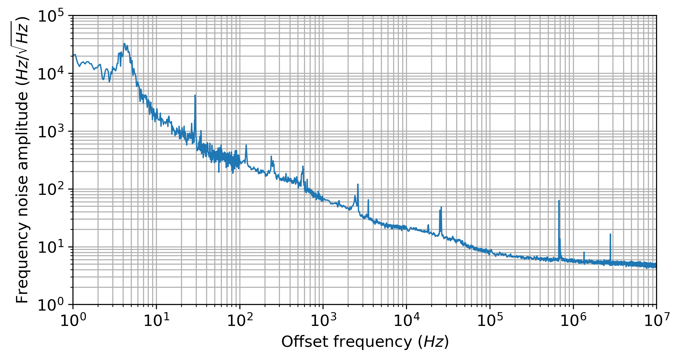
Figure 1 Laser output frequency noise at 640mA pump current. Measured with OE wave 4000 noise analyzer.
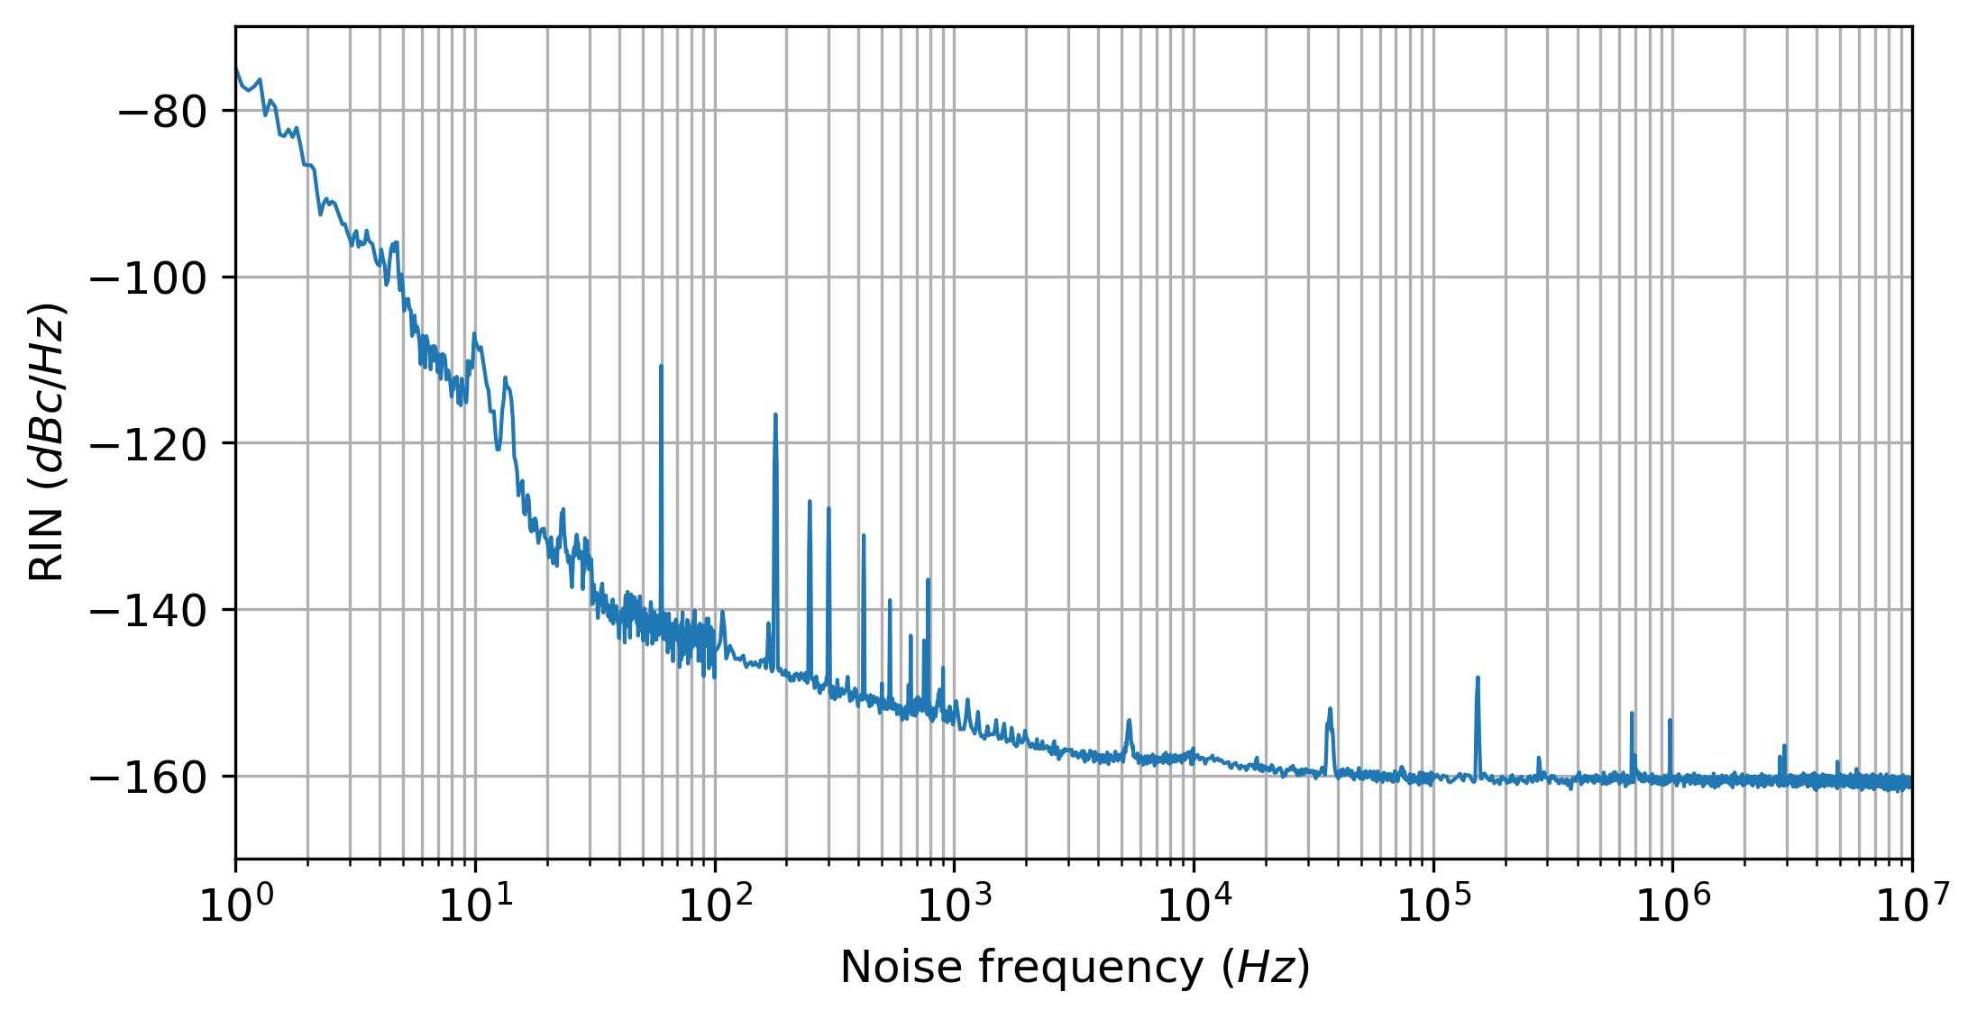

Figure 2 Laser relative intensity noise at 640mA pump current. Measured with OE wave 4000 noise analyzer.

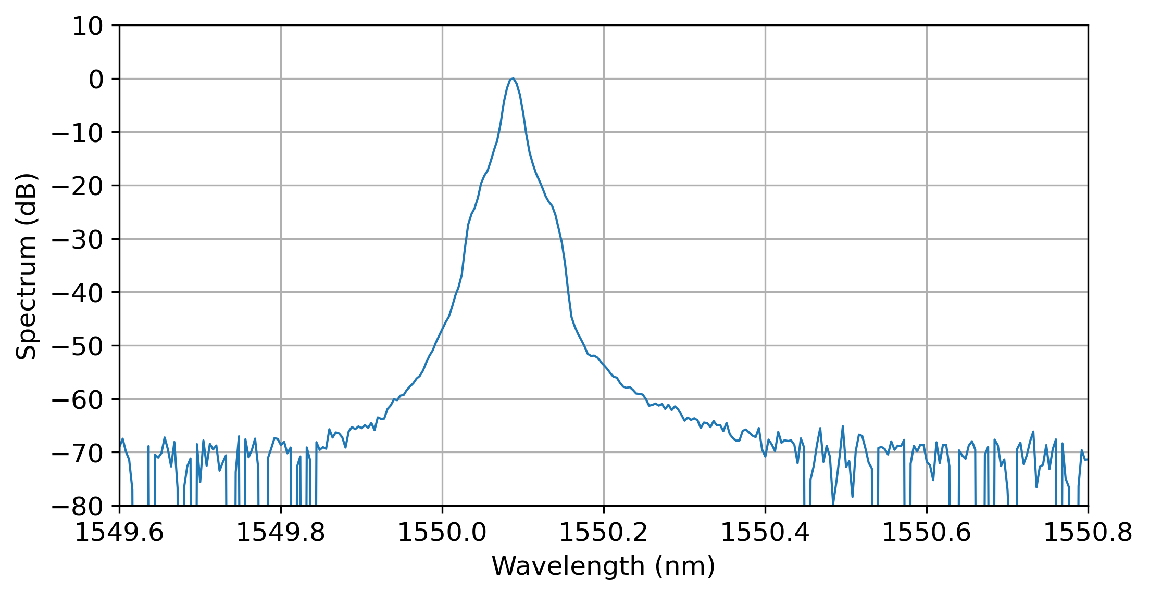
Figure 3 Laser output spectrum at 640mA pump current, measured with Yokogawa AQ6370D OSA, limited by OSA resolution bandwidth 0.02nm.
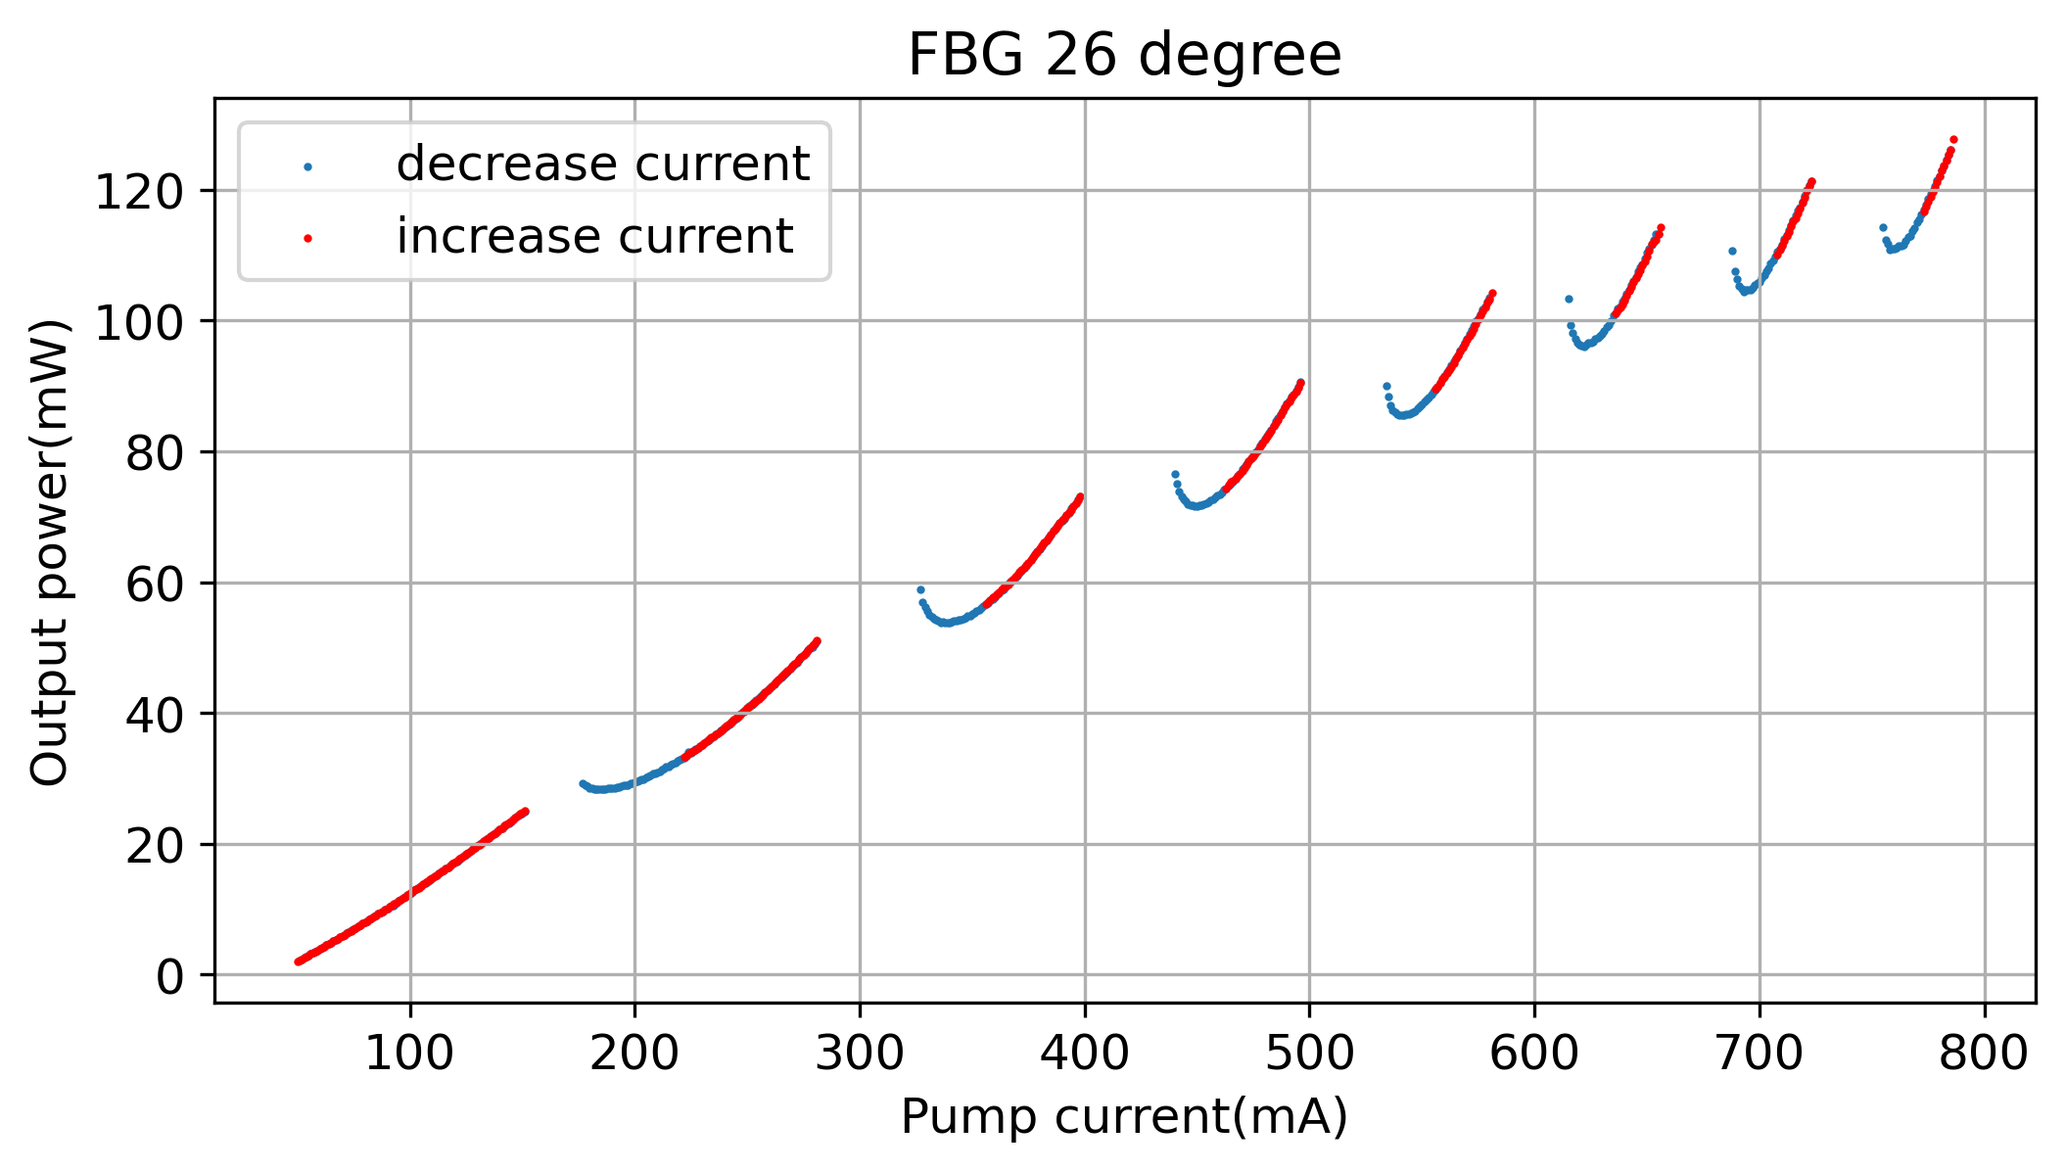
Figure 4 Output power for single-mode only regions, FBG temperate at 26°C.
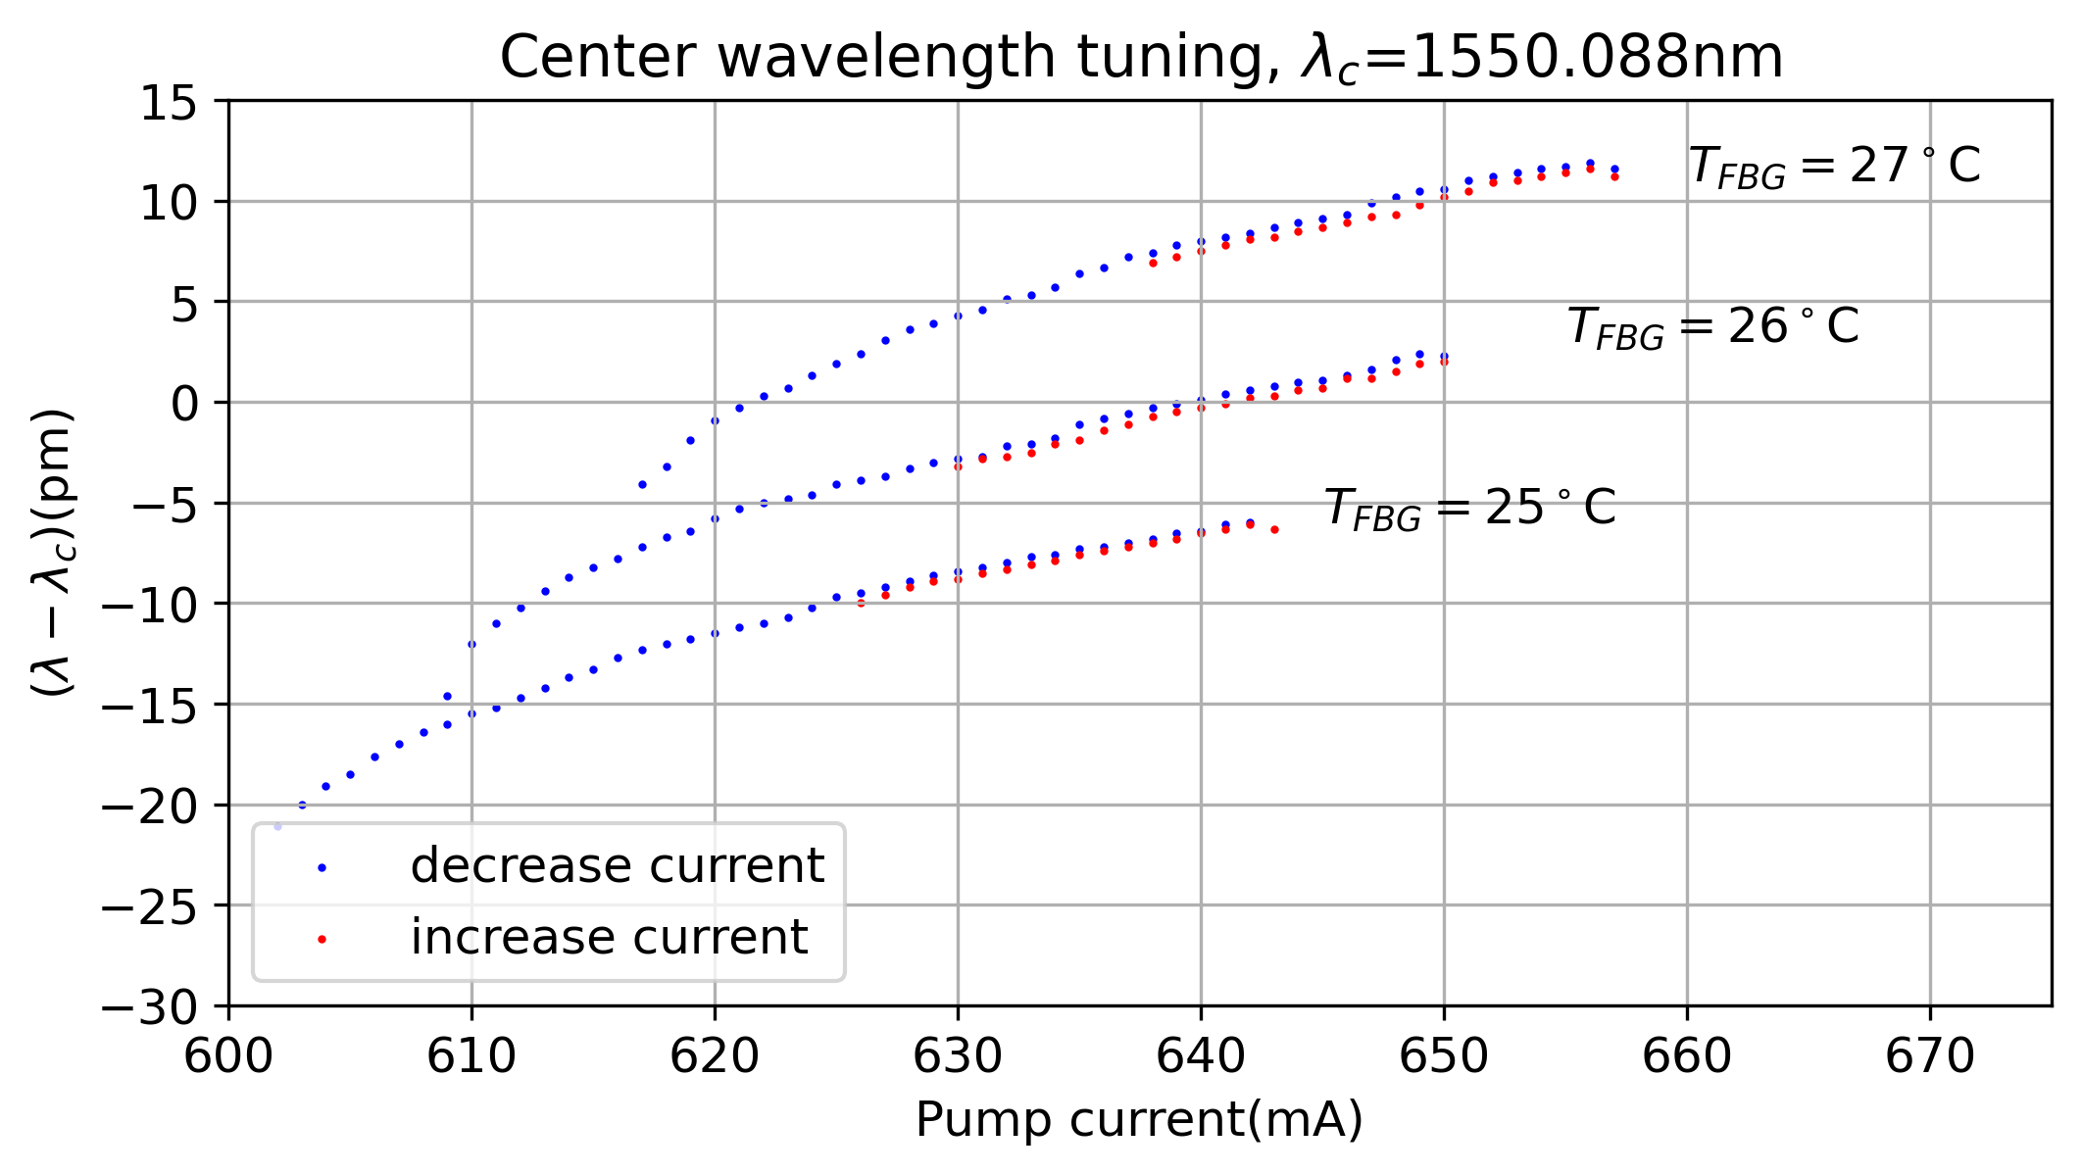
Figure 5 Center wavelength turning with pump current and FBG temperature, device is factory set to 640 mA, 26°C FBG temperature.

