LIGO Laboratory / LIGO Scientific Collaboration

LIGO- M2400206 -v1 LIGO 7/1/2023

Standard Operating Procedure
for the 45mW, 780nm Thorlabs Laser
in West Bridge B102

Torrey Cullen and Lee McCuller

Distribution of this document:
Lasers and Optics

This is an internal working note
of the LIGO Project.

California Institute of Technology  LIGO Project – MS 100-36  1200 E. California Blvd.  Pasadena, CA 91125  Phone (626) 395-2129  Fax (626) 304-9834  E-mail: info@ligo.caltech.edu | Massachusetts Institute of Technology  LIGO Project – NW22-295  Cambridge, MA 02139  Phone (617) 253-4824  Fax (617) 253-7014  E-mail: info@ligo.mit.edu
LIGO Hanford Observatory  P.O. Box 159  Richland WA 99352  Phone 509-372-8106  Fax 509-372-8137 | LIGO Livingston Observatory  P.O. Box 940  Livingston, LA 70754  Phone 225-686-3100  Fax 225-686-7189

http://www.ligo.caltech.edu/

Introduction
This document is the Standard Operating Procedure (SOP) for 780 nm, 45 mW DBR Butterfly Laser with Isolator, PM Fiber, in West Bridge B102. This laser is used to lock to a Rb vapor cell for the RBQ experiment.
Thorlabs' DBR780PN Distributed Bragg Reflector (DBR) laser is a single-frequency laser diode that is well-suited as a low-noise pump source for a rubidium atomic clock.
This laser is a Class 3B laser outputting 45 mW max at 780 nm. Direct eye exposure to Class 3B lasers is hazardous. Direct exposure to skin is a potential hazard.

Room B102
The floor plan of Room B102 is shown in Figure 1. The area indicated by hatching is the Nominal Hazard Zone. The area between the laser safety barrier and the entrance door is non-hazard area that is designated for storing and donning laser safety glasses. 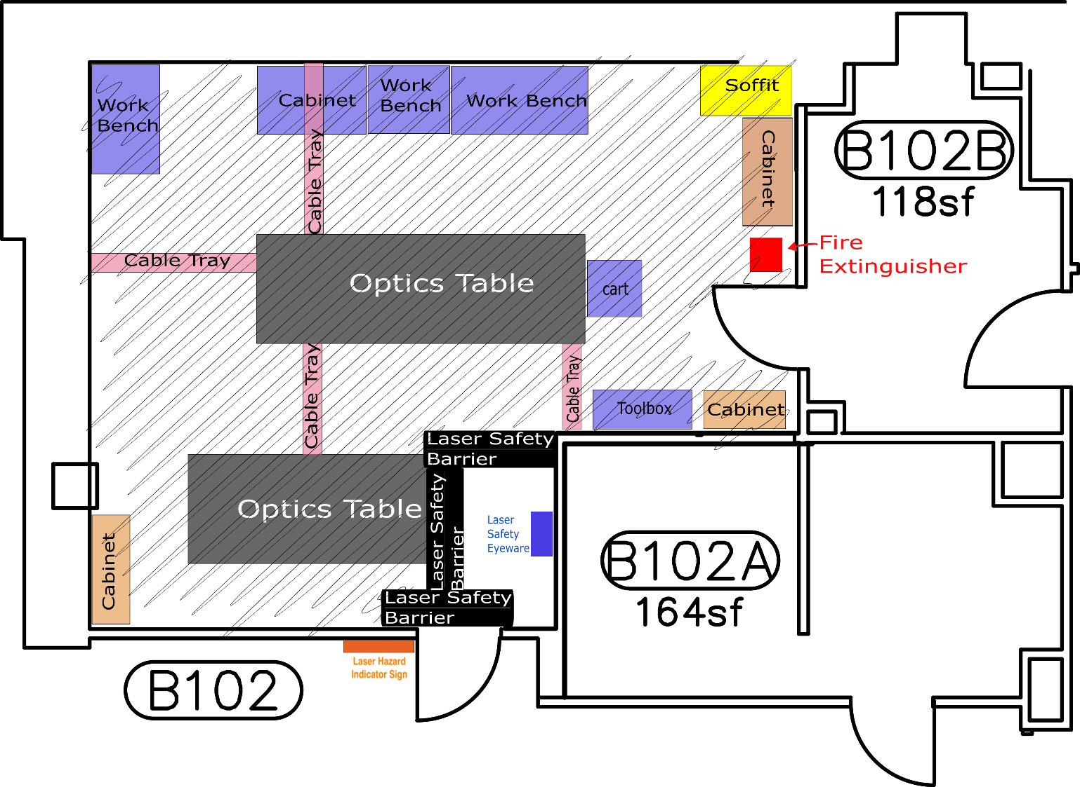
Figure 1. The floor plan for Room B102.

Hazards

Laser Radiation Hazards
The FBG laser is an infrared laser and is invisible to the naked eye. The output power of this laser alone can be operated above the accessible emission limit (AEL) of 1.9 mW and 96 mW for both eye and skin respectively. With the amplifier in use, the output can be operated at well above the AEL. Extreme caution should be taken when operating the laser with the amplifier.

Electrical Hazards
The system is powered using the recommended 2 V and .250 A for the operating voltage/amperage respectively. There are no electrical hazards when operating the laser.

Hazard Controls

Access Controls
There are no active access controls to West Bridge Room B102.

Beam Controls
There is a Laser Enable PushButton Switch that be used to shutter the laser. The laser will remain on at all times to increase the operating life length of the laser.

Safety Sign

A laser hazard indicator sign is located at the outside of the room. Whenever there is a possibility to use the laser beam for a task, this sign should be turned on by a switch next to the entrance door.

Laser Safety Eyewear
The use of laser safety eyewear is mandatory whenever the laser power supply is energized. A minimum optical density (OD) of +3 at 1550 nm is required. When the amplifier is introduced a minimum of OD 7+ 1550nm is required. C2KG5 laser safety goggles are stored in the entrance area. These goggles have filtering at the following wavelengths:
OD 6+ @530-570nm
OD 4+ @655-664nm
OD 5+ @665-679nm
OD 6+ @680-695nm
OD 7+ @696-1550nm
Always double check the listed filtering on the side of the goggles before entering the laser hazard area.

Handling of the optical fiber
The laser source output is a PM, FC/APC Bulkhead optical fiber. This will initially be connected to a fiber coupler, where the max output of this fiber is 45 mW. The laser source should be turned off when handling the output fiber.

Training
Users of any laser should have received the LIGO Project’s basic laser safety training. They are not permitted to operate the laser by themselves until they have received this training.

Operating Procedures
Items such as jewelry and watches should not be worn while manipulating beams on the optical table.
Caution should be exercised when one’s head passes through the plane of the laser beam.
Prior to turning on the laser or enabling via the Laser Enable PushButton Switch:
- check the beam path to ensure that there are no reflective objects in the beam path that may unintentionally deflect the beam
- alert any personnel in the room that the laser is about to be operated and ensure that everyone is wearing the appropriate laser safety eyewear
- check that the laser warning sign is illuminated
Prior to turning off the laser, placing the laser in standby or close the shutter:
- scan the optical table for any stray beams and correct the situation as necessary.

Emergency Procedures
In case of an emergency, call x5000.

